Heading 4

Marlene Zentz, UMOnline/PCC

When using complex images, include Alt text as you would for any other image, but also include additional description as a caption. If more description is needed, include it in the content of the page.

This graph illustrates how your grade in this course is derived from the following category weights:

* Attendance/participation – 10%
* Assignments – 10%
* Midterm website – 20% HTML hand-coded course website
* Design document – 20%
* Final Project – 40%

Table Column Header

Sufficient Color Contrast

http://www.umt.edu/dss/http://www.umt.edu/dss/

http://www.umt.edu/dss/http://www.umt.edu/dss/

Heading 3

Heading 3

Heading 3

Heading 4

Heading 3

Heading 3

Format lists as proper lists

Heading 3

Heading 2

# Syllabus (sans serif font)

## UM 101 – Introduction to Online Learning

### Course Information:

* Instructor: Jane Doe
* CRN: 12345
* Credits: 3
* Term: Summer 2014

### Instructor Information:

Hello! My name is Jane Doe, and I’ll be your instructor for this course. I’ve taught this course online for the past two years. Each time I teach it, I learn something new.

### Assignments/Assessments:

#### Grading Scale

| Grade | Grading Scale by Points | Grading Scale by Percentages |
| --- | --- | --- |
| A | 202 – 225+ | 90 – 100% |
| B | 180 - 201 | 80 – 89% |
| C | 157 - 179 | 70 – 79% |
| D | 135 - 156 | 60 – 69% |
| F | < 134 | <59% |

#### Late Work and Make-up Policy

Assignments must be completed on time in order to earn full credit. *(Late assignments will earn 50% credit.)*

#### 

#### Late Work & Make-up Policy

Assignments must be completed on time in order to earn full credit.

(Late assignments will earn 50% credit.)

Write using self-describing links

Heading 1

Anatomy of an Accessible Syllabus

t

### Disability-Related Modifications:

Students who experience disability-related barriers should contact [Disability Services](http://www.umt.edu/dss/) (http://www.umt.edu/dss). If students elect to use approved academic adjustments, they must provide in advance formal notification from Disability Services to

the instructor.

## **UM 101 Grading Category Weights** **(Best Practices when using complex graphics)**

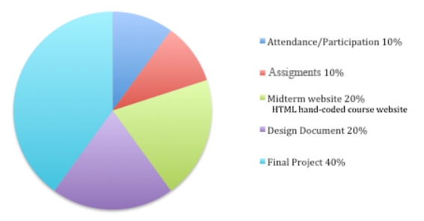

t